IOT BASED STREET LIGHT SHORT CIRCUIT DETECTION
Mrs.Suhasini ¹,Ms.Anjali Kashyap S², Mr.Drupad S³,Ms.Gaargi B⁴, Mr.Karthik S⁵
¹ Assistant Professor, Dept. of Computer Science and Engineering, Maharaja Institute of Technology, Thandavapura
^{2,3,4,5}Students, Dept of Computer Science and Engineering, Maharaja Institute of Technology, Thandavapura
---------------------------------------------------------------------***---------------------------------------------------------------------

Abstract - The project outlines a cutting-edge system that integrates short circuit detection, fire accident detection, and light intensity optimization features into street lighting infrastructure. The system utilizes IoT and an Arduino Uno microcontroller to enhance safety, efficiency, and sustainability. The system's core feature is its ability to identify short circuits and the exact location of short circuit and alert authorities promptly. Additionally, the system incorporates fire sensors to detect fire accidents and optimizes light intensity based on environmental conditions. Overall, the system offers a comprehensive solution for enhancing street lighting infrastructure.

Key Words: Short circuits , Fault detection, Power distribution lines,Microcontroller,GSM mobile,IoT devices and sensors,Voice alert.

1.INTRODUCTION

Street lighting is a very crucial aspect of public safety and security as it provides adequate illumination during nighttime. However, various issues like short circuits and fire accidents can pose significant risks to both infrastructure and public safety. Inefficient energy usage in street lighting systems also contributes to environmental concerns and operational costs. To address these challenges, the project proposes a comprehensive Street Light Short Circuit Detection and Optimization System that makes use of Internet of Things (IoT) technologies.
The proposed system integrates various sensors, including switches that detect short circuits, Light Dependent Resistors (LDR sensors), and flame sensors, to monitor and detect potential hazards in street lighting infrastructure. The short circuit detector switches detect electrical faults such as short circuits in street lights. Whenever a short circuit is detected, the system initiates an alert mechanism that notifies designated authoritative personnel, enabling prompt intervention to mitigate the issue and ensure public safety.
In order to detect fire accidents in the vicinity of street lights, fire sensors are used into the system. Detecting the fire hazards allows for timely response measures, reducing the risk of property damage and ensuring the safety of nearby residents.
The system utilizes LDR sensors to change the level of intensity of street lights based on ambient light conditions, optimizing energy usage and promoting sustainability. During nighttime, when ambient light is low, the system automatically increases the intensity of street lights to maintain adequate illumination for safe navigation. Conversely, during daytime, the system reduces the intensity of street lights to conserve energy without compromising safety.
Apart from the hardware components, the project includes development of a mobile application using the Java programming language. This application serves as a user interface for authoritative personnel to receive alert messages and take necessary actions, such as shutting down power lines to specific street lights in the event of a detected fault or hazard.
Overall, the proposed Street Light Short Circuit Detection and Optimization System offers a proactive approach to enhancing the safety, efficiency, and sustainability of the infrastructure of the street lights through real-time monitoring, detection, and responsive control mechanisms. The system has the ability to significantly decrease the risks associated with street lighting infrastructure while promoting sustainable practices, making it an ideal solution for modern cities.

1.1 PROJECT IDEA

Our project endeavors to craft an IoT-powered smart street lighting management system by integrating sensors like short circuit detectors, LDR sensors, and flame sensors, with a mobile application that enables remote monitoring and control. This system is designed to bolster safety measures, optimize energy consumption, and make urban lighting infrastructure maintenance more efficient.

1.2 MOTIVATION OF THE PROJECT

The motivation behind this project stems from the need to address the growing challenges faced by power distribution systems. With electricity consumption on the rise and distribution failures causing frequent service interruptions, there exists a critical demand for innovative solutions to increase the level of reliability and efficiency of power networks.

1.3 GOALS AND OBJECTIVES

1. Design an intelligent IoT-based system for managing street lights:
• The system must employ IoT technology to monitor and regulate street lights.
2. Detect electrical faults and fire hazards:
• Integrate Short Circuit Detector Switches and Flame Sensors to quickly identify electrical faults and fire incidents.
3. Optimize lighting intensity:
• Use LDR sensors to dynamically adjust street light intensity, ensuring optimal illumination levels at night and conserving energy during the day.
4. Enable real-time alerting:
• Develop a mobile application using Java to alert relevant personnel of any incidents detected, allowing for swift intervention.
5. Allow for remote control:
• Provide authorities with the ability to remotely manage street lights, including the option to turn off power to specific lights in the event of an emergency.
6. Enhance safety and efficiency:
• Improve safety on the streets by identifying and addressing electrical faults and fire hazards while encouraging energy conservation to promote sustainable urban development.

1.4 RELATED WORK
1: The paper titled "Street light controller with sg technology" was published in 2020. The paper outlines a system for streetlight monitoring with modules for lamp switching, sensor integration, and GSM-based control. It is developed to achieve efficient and effective street lighting management.
2: In 2020, a technical paper titled "IoT Based Automatic Street Light Control and Fault Detection System" was authored by M. Vasantha Lakshmi and others. The paper presents a system that utilizes Raspberry Pi3 and LDR sensors for automated day/night streetlight control, enhancing energy efficiency while reducing costs. The IoT-based system integrates Raspberry Pi3 and LDR sensors for streetlight control and fault detection, enabling real-time monitoring of light intensity and prompt detection of faults.
3: A new system was introduced in 2021, which uses an IR sensor and an LDR to control the brightness of streetlights. Its purpose is to improve energy efficiency and security. Automated streetlights are equipped with an LDR for control, built-in fault detection mechanisms, and instant alerts to authorized personnel during faults. These IoT-based streetlights are a cost-effective and low-maintenance solution for sustainable urban lighting.
4: In 2021, Krunal Khobragade, Kundan Gaikwad, Pravin Bhiogade, Akshay Pardhi, and Sonali Kharwade published a technical paper on "GSM Based Automatic Street Light Control System". The innovative system uses light-dependent resistors (LDRs) to switch off streetlights in bright light and turn them on in darkness. It also includes adaptable LEDs that adjust intensity based on inputs from passive infrared (PIR) sensors. The system communicates via GSM, making maintenance easier, and provides status updates. The paper gives a presentation of smart lighting solution that aims to conserve energy, enhance urban lighting infrastructure, and improve safety.
5: "Smart Street Light Monitoring System Based on Inter net of Things, Using GSM for Monitoring" is an academi c article published in 2022. The system leverages IoT a nd GSM technology to provide flexibility light, problem tracking, and userfriendly light failure alerting. It can adjust the brightnes s according to the environment to save energy and sou nd the alarm when the light does not work, promoting energy saving and good maintenance
6: The article titled "Internet of Things Based Automatic Broken Street Light Fault Detection and Management System" describes a process that uses IoT and GSM technology to adjust the brightness of smart street lights, search for problems, and notify mobile phones to save energy. and good care. . The Raspberry Pi program controls street lights, uses cloud storage to detect faults, and provides effective control by controlling on/off based on the weather measured by the LDR.
2. PROPOSED SYSTEM

Identifying a short circuit in a power distribution line is one of the complex and critical issue in the power system. Our solution, designed with a microcontroller, GSM mobile, driver circuit, control circuit interfaced with a GSM modem and advanced IoT devices, enables remote supervising and overseeing of multiple stand-alone distribution transformer plants. Under normal conditions, the system records and periodically reports overall performance. However, if incorrect behavior is detected, the operators are immediately informed. Users can also modify plant elements and measurement system settings with appropriate instructions. To cater to specific operative conditions, various communication means and plant configurations are available. Our microcontroller-based protection of electric distribution system offers effective monitoring and sends information about the distribution system, allowing for exact location of the disorder. For general, flexible, and cost-effective implementation, the remote communications are based on powerful GSM networking. In case of interruption such as a short circuit, the microcontroller provides an immediate indication through the GSM modem and IoT Devices. The signal is received by the GSM modem and data is sent from the distribution side to the substation and to the line patrol staff as a message. A voice alert is also made to alert the staff, who can subsequently find the exact location where the fault has occurred. 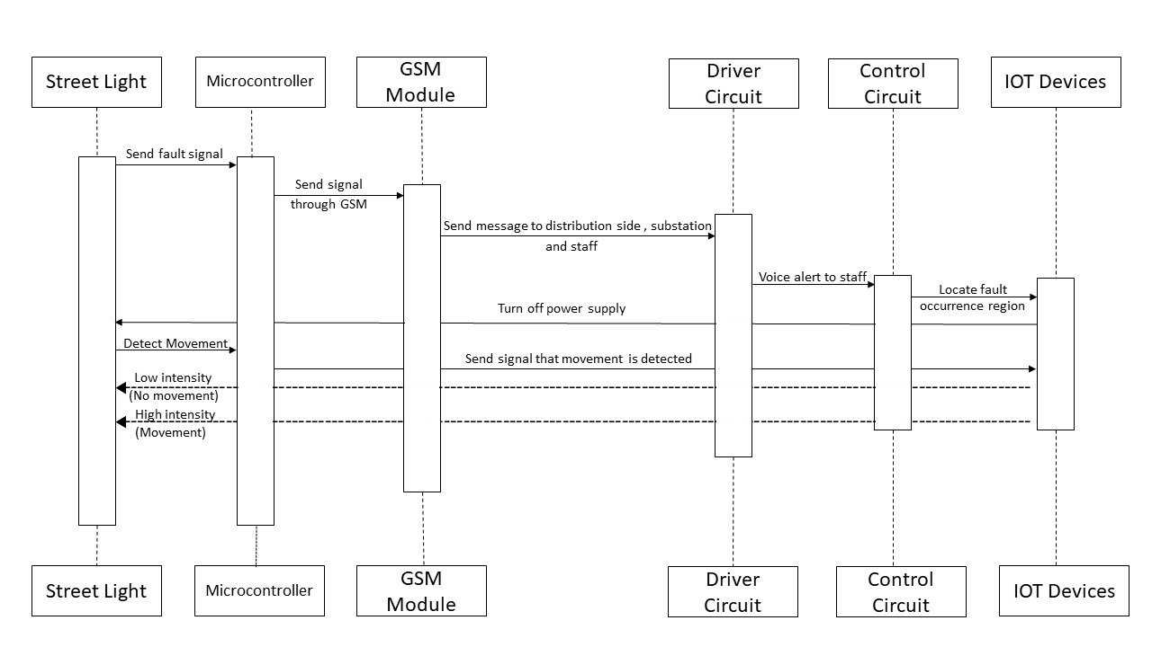
Fig 1: Sequence Diagaram

3.WORKING PRINCIPLE

The distribution line fault detector, which utilizes GSM technology, operates through a microcontroller. As the distribution line has a voltage of 220v, 50Hz power supply, it is not viable to directly connect it to the working kit. Instead, switch devices are used to generate a short circuit in the line when a fault occurs. An immediate signal is sent to the microcontroller, which then generates a message and sends it to the Electricity Board Authority via GSM. If suppose the authorized person's mobile phone is in silent mode, the message alert automatically converts it to general mode, and the person is alerted. The GPRS system, along with an IoT application, helps the authorized person determine the exact location of the short circuit. The same process is followed when detecting a fire in Power Transmission Lines or near transformers. Furthermore, the Optimized Street light short circuit detection system, which operates based on intensity or vehicle movements, is also integrated into the same system.

4. SYSTEM ARCHITECTURE

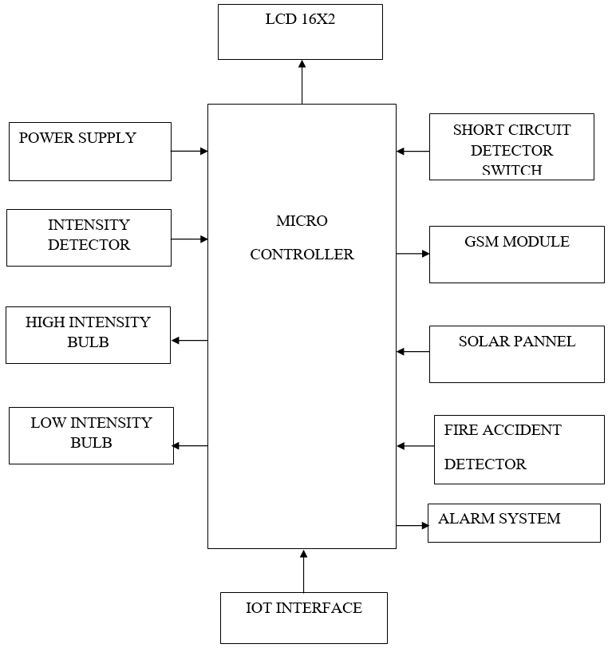
Fig 2: System Architecture
In IoT system architecture,it incorporates a network of interconnected components like short circuit detector switch, light intensity sensors, and flame detectors,all this components are integrated with microcontroller for real-time processing. Street lights are equipped with these sensors used to detect short circuits and optimize their intensity based on ambient light levels, while also being equipped with flame detectors to identify fire accidents. Data from these sensors are transmitted via GSM modules to an IoT interface, enabling remote monitoring and control for efficient management of street lighting and rapid response to potential hazards.
5. IMPLEMENTATION
A street light monitoring system requires a number of steps and considerations to be taken. Here is a general outline of the implementation process:
1. Select sensors that are appropriate for the desired data collection parameters and install them in each street light, ensuring proper placement and connectivity.
2. Build a communication network to link the street lights and make data transmission simpler. Select the appropriate network technology (e.g., wireless or wired) in accordance with the coverage area, available infrastructure, and data transfer requirements. Ensure that all necessary network components, such as gateways, routers, or access points, are set up.
3. Assemble the on-premises or cloud-based central monitoring system. To collect, store, analyze, and manage data from the street lights, install the necessary hardware and software components. Set up the system to analyze and handle data in real time.
4. Develop or configure the control and management features of the system.This includes the ability to remotely monitor the operational status of street lights, receive notifications or alerts for faults authentication and access control mechanisms for system administrators.
5. Thoroughly test the street light monitoring system before deployment to ensure proper functionality and performance.Deploy the system in the target area, and ensure that there is proper connectivity and synchronization.Establish a maintenance plan to monitor the system's performance, conduct regular updates, and address any issues that may arise.
6. CONCLUSION

The suggested approach for identifying faults in power lines involves incorporating IoT devices such as microcontrollers and GSM-based systems. This method enables swift recognition of short circuits and their prompt rectification of faults in power lines without manual power. Instead, the GSM system transmits real-time messages to the relevant personnel and power station. The microcontroller, due to its high efficiency and affordability, can endure temperatures up to 100 degrees Celsius. The enhancement of fault detection and rectification is not the only benefit of this system it also improves the intelligence of street lights by leveraging natural light and vehicle movements to control their illumination.

7.RESULTS

IoT-based automated streetlight infrastructure is a cost-effective solution. With consistent monitoring, staff or routine inspections are no longer necessary, which effectively minimizes problems like delayed short circuit detection and prolonged downtimes. This system optimizes the intensity of the street light to reduce energy wastage, resulting in accurate and reliable outcomes within the specific field.

ACKNOWLEDGEMENT

We wish to express our deepest appreciation to our esteemed Project Guide, Prof. Suhasini, whose invaluable guidance and suggestions have propelled our project beyond our expectations. We extend our heartfelt gratitude to our Project Coordinator, Dr. HK Chethan, for his unwavering support and dedication in helping us complete this project within a tight timeframe. We would also like to acknowledge our Head of Department, Dr. Ranjit KN, for fostering an environment that encourages innovation and practical application of our academic curriculum. Finally, we extend our sincerest thanks to our Principal, Dr. Y T Krishne Gowda, for providing us with a golden opportunity to carry out project on the topic of 'IoT-based Street Light Short Circuit Detection', and for his unwavering support in our research and learning endeavors.

REFERENCES

[1]-S. Srivastava, “Automatic Street Lights”
[2]-V.V.S. Madhuri, P.Mallikarjuna Sarma, N.SandhyaRani, “Automatic Street Lighting using PLC”
[3]http://www.engineersgarage.com/electroniccomponents/atmega16-microcontroller
[5]http://www.electroschematics.com/6355/ldr-lightdependent-resistor-photoresistor
[6] https://www.nowsms.com/faq/what-is-a-gsm-modem
[7]http://www.edgefxkits.com/blog/light-dependentresistor-ldr-with-applications.

